STALLION SILENT AUCTION

2010 CALIFORNIA C-N FUTURITY

FEATURED STALLIONS: ALL BIDS START @ $100

[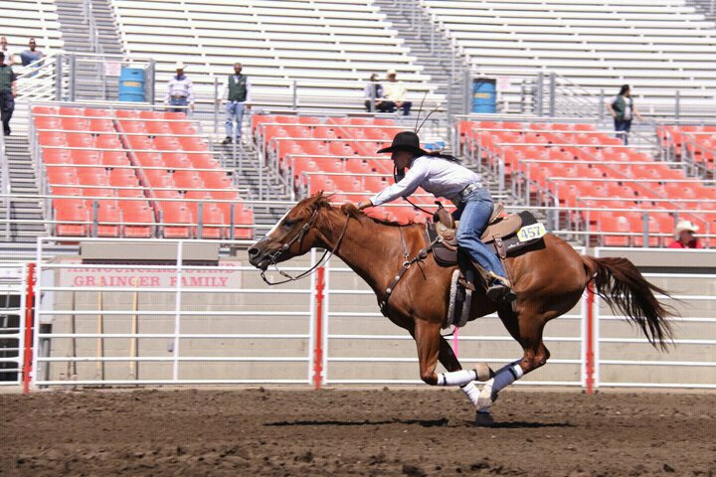](http://www.facebook.com/photo.php?pid=31475331&id=1321862422)

STORMIN ED as of 9-6-10 High Bid $200

Sire: Mito Jet By Mito Paint  
 Dam: Quinto Miss By Limit's Regards

www.pamrossbarrelhorses.com

Picture shown is of Stormin Ed's Fillies, 5 yrs old, Salinas Rodeo 2010. Picture of stallion coming soon!

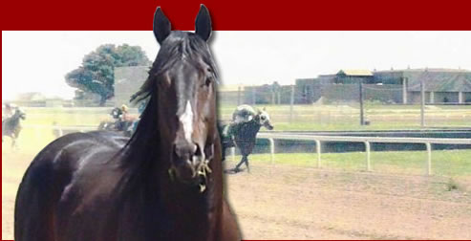

HI ON THE WINE Open Bid

Sire: Jazzin Hi By Merridoc  
Dam: Jazz N Wine By Assured Copieto

www.melloranch.com

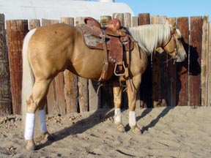  
FIRST DOWN FRENCH as of 9-6-10 High Bid $600  
  
Sire: Frenchmans Guy By SunFrost  
Dam: A Flashy Dash By A Classic Dash

www.shiningmranch.com

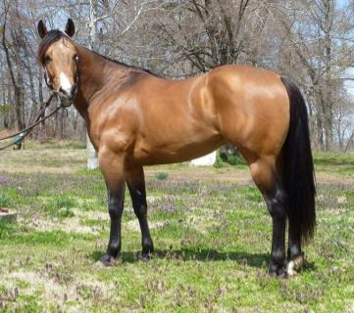

FRENCHMANS FURY as of 9-6-10 High Bid $200

Sire: Frenchmans Guy By SunFrost  
Dam: Lola Oh's By Fancy Oh's

www.frenchmansfury.com

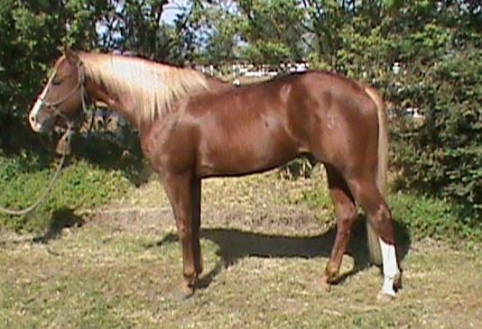

BOONDOC PLAYBOY T Open Bid

Sire: The Playboy Channel By Freckles Boone  
 Dam: Sugs Clearwater Ann By Sugs Chita

www.cookperformancehorses.com

[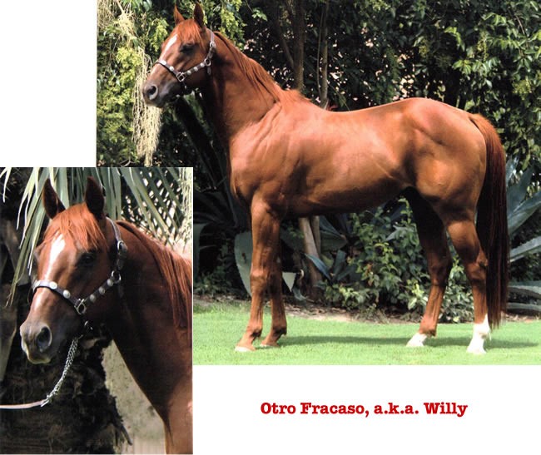](http://lyndeestairs.com/2010pics/otrofracasolarge.jpg)

OTRO FRACASO as of 9-6-10 High Bid $150

Sire: Willie Wanna Dash By First Down Dash  
My Sister Sarah By Liquid Charge

www.lyndeestairs.com

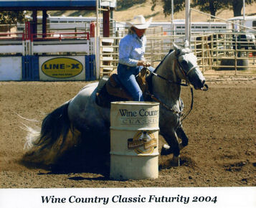  
 MP HAYPATCH TIGER Open Bid

Sire: PC Frenchmans Hayday (Dinero) By SunFrost  
 Dam: Rose Patch By Lay A Patch

www.grohlranch.com



EXCLUSIVE RED MAN Open Bid

Sire: Red Man Stick By Dinky's Red Man  
 Dam: Exclusively Howie By Howie Bars

www.lausdeohorses.com

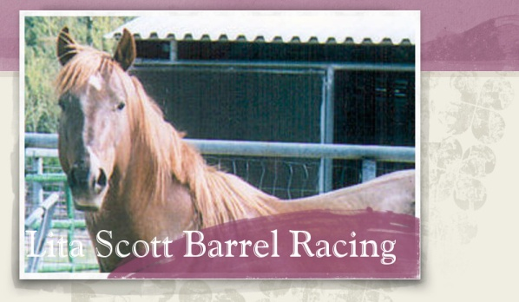HONOR THY MARC Open Bid

Sire: Jet of Honor By Jet Deck  
Dam: Mercy Doc By Nevada Doc

www.lscottbr.com

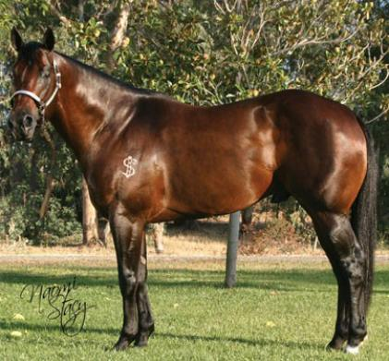

KS CASH N FAME as of 9-6-10 High Bid $200

Sire: Dash Ta Fame By Easy Jet

Future Fortune Stallion!!!

www.dugolivestock.com

Parade of Stallions for the

2010 CALIFORNIA C-N FUTURITY  
  
Thank you to the below Sponsors for this group of *AMAZING* stallions!!!  
These stallions below have been ***PROVEN*** in the Barrel Racing industries.  
  
You will find below Arena Record Holders.  NFR Qualifiers. Sir's of NFR Qualifiers.   
All Round Proven Horses in Barrel Racing, Roping, and Breakaway  
  
You will find horses of ALL colors  
Black, Bay, Sorrel, Grey, Palomino, Roan, Sorrel w/Flaxen, Buckskin  
You will find: Stocky, Lean Running Style, Thick and Strong!  
You will NOT find a better variety of stallions in one place.  
  
Have FUN and Happy Bidding!!!  
  
Thank you to all the Stallion Owners for your donations!!!!  
It is because of you, this Futurity ***is going to be*** successful!!!  
100% of the proceeds will go to the C-N Futurity held December 4 and December 18, 2010  
C-N Arena, Lemoore, CA ... Excellent Ground. Standard Pattern! Perfect for the young horse

Bidding Rules:  
Each Stallion Bid will start at $100.    
You may call: 559-469-7406 or email: [brlrcr@lemoorenet.com](mailto:brlrcr@lemoorenet.com) OR at the office at any C-N Barrel Race in Lemoore, CA for the "CURRENT" high bid and to place a bid.  
ALL BIDDERS will be kept confidential until winner is announced...(All Bid info will be posted at end of auction)  
High bidder will be contacted immediately when they have been out bid.  
Bidding ends November 20 at the last c-n barrel race before the futurity in December 2010.  
all fees must be paid to Charleen Ornellas by December 1, 2010. (Winners will be posted Nov 20, 2010)  
This Auction covers "Breeding Fee". any mare care or vet requirements such as AI must be discussed with the stallion owner and/or your veterinarian.   
If you have any questions feel free to contact me at the below number or email address.  
Thank you,  
  
Charleen Ornellas  
559-469-7406  
[brlrcr@lemoornet.com](mailto:brlrcr@lemoornet.com)